Question 2
Q2(B) – Technical Support Ticket Navigator
A software company maintains active technical-support tickets dynamically. Every ticket contains
Ticket_ID and Priority, where priority is between 1 and 5. The support engineer works with one ticket
at a time and must be able to move both forward and backward through the active tickets.
New tickets must always follow this business rule: higher-priority tickets appear before lower-priority
tickets; if two tickets have the same priority, the ticket received earlier remains first.
Develop a dynamically allocated program supporting these commands:
NEW id priority – Create a new ticket and place it in its correct position.
NEXT – Move the engineer to the next ticket, if one exists.
PREVIOUS – Move the engineer to the previous ticket, if one exists.
RESOLVE id – Remove the specified ticket from the active ticket collection.
CHANGE id newPriority – Change the priority of the specified ticket and reposition it so that all
business rules remain satisfied.
SHOW – Display all active tickets from first to last as Ticket_ID and Priority.
SHOW_REVERSE – Display all active tickets from last to first.
CURRENT – Display the ticket currently selected by the engineer.
Additional Programming Requirement
Maintain a variable that counts the number of link modifications performed during every NEW,
RESOLVE, and CHANGE operation. After each such operation, display the number of link modifications.
At the end of execution, display the total number of link modifications.
The program must correctly handle:
• initially empty collection and only one ticket
• highest- and lowest-priority insertion
• several tickets with the same priority
• resolving the first, last, or current ticket
• changing a ticket from low to high priority and high to low priority
• invalid Ticket_ID
• movement beyond the first or last ticket

CODE:
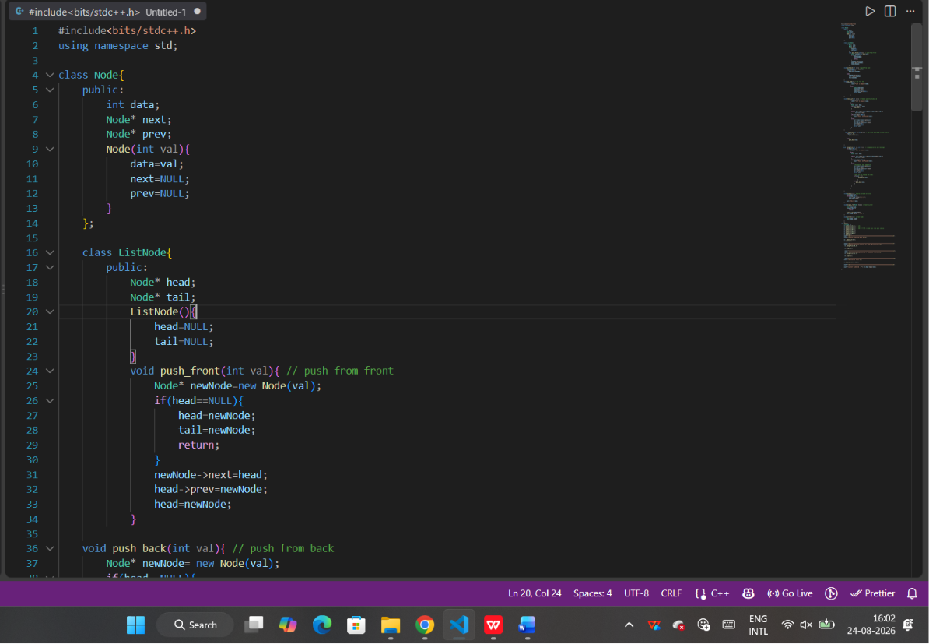
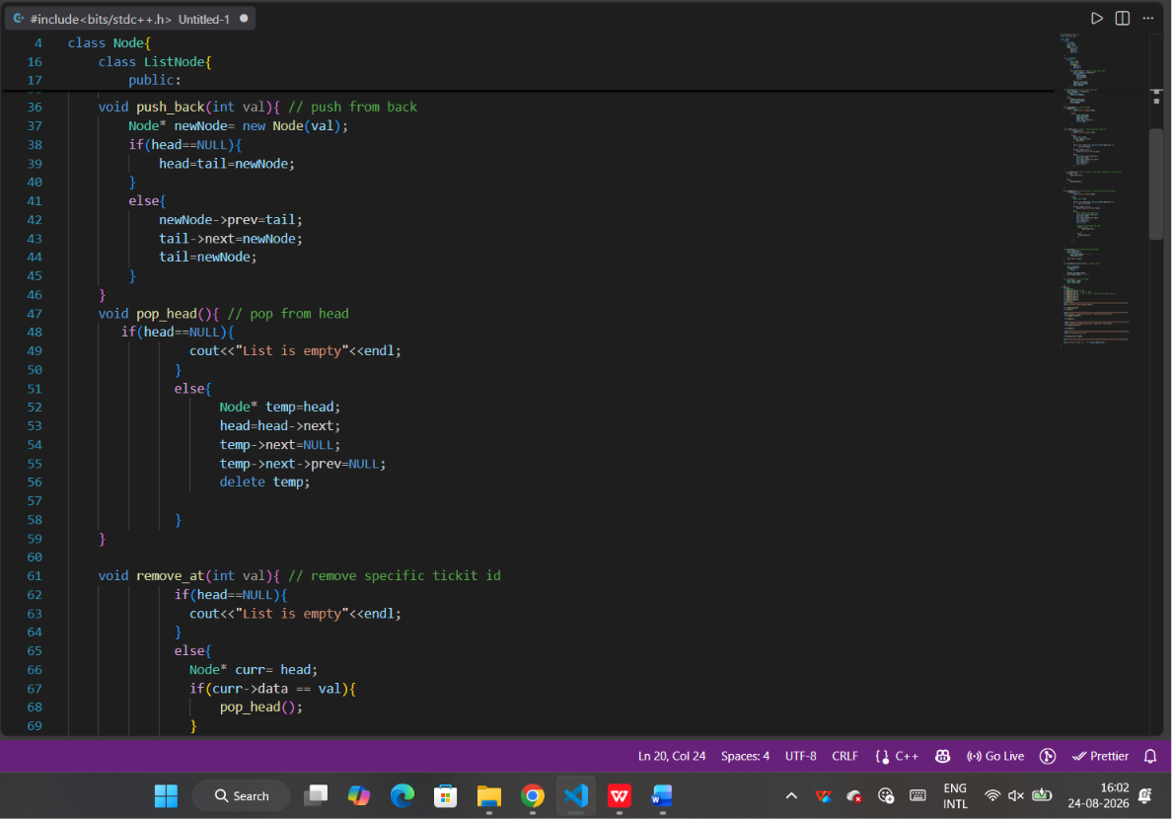\
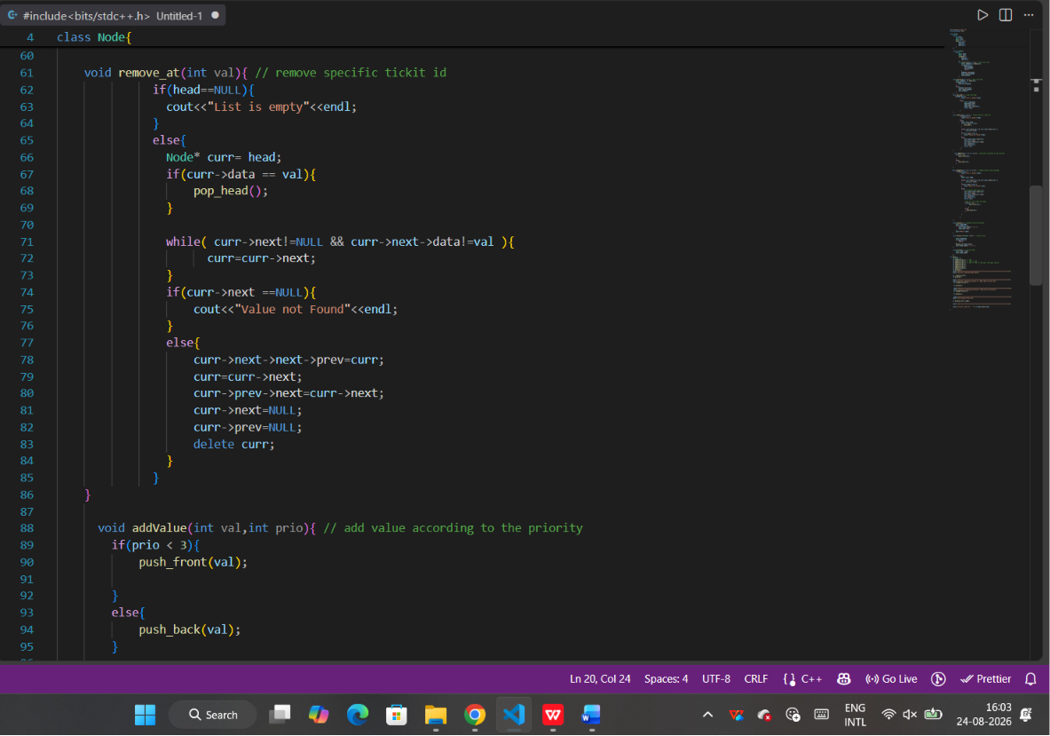
/
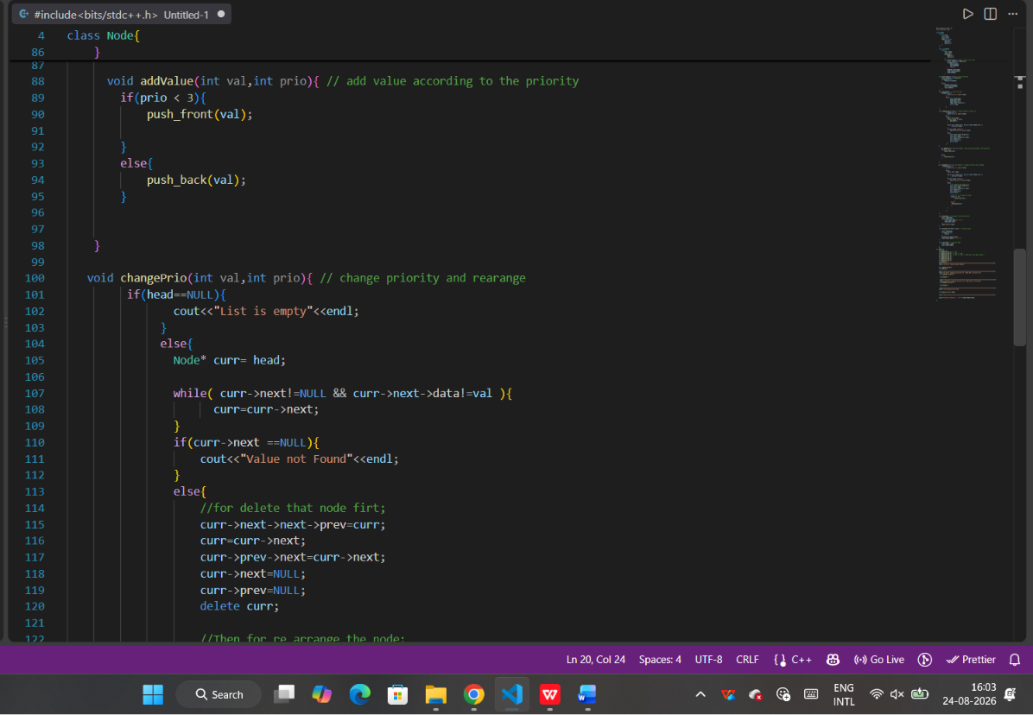
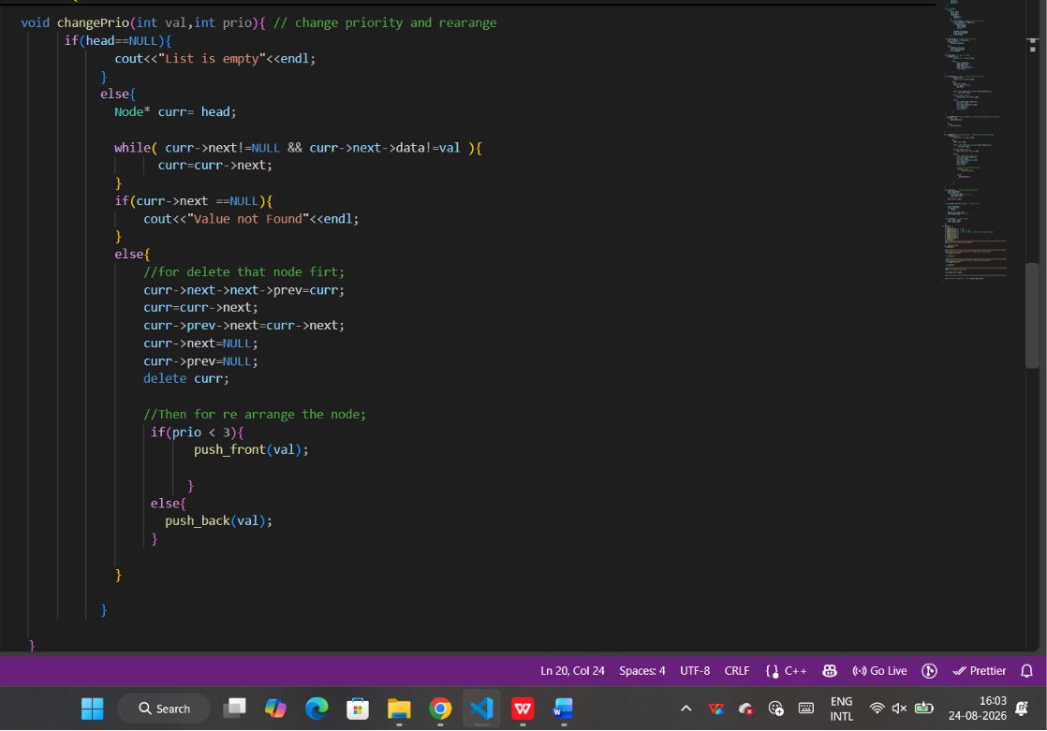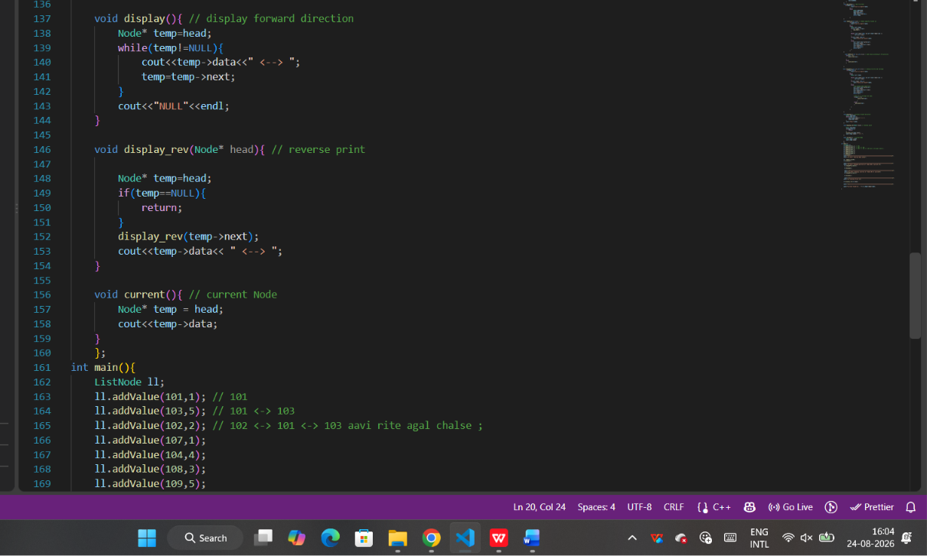
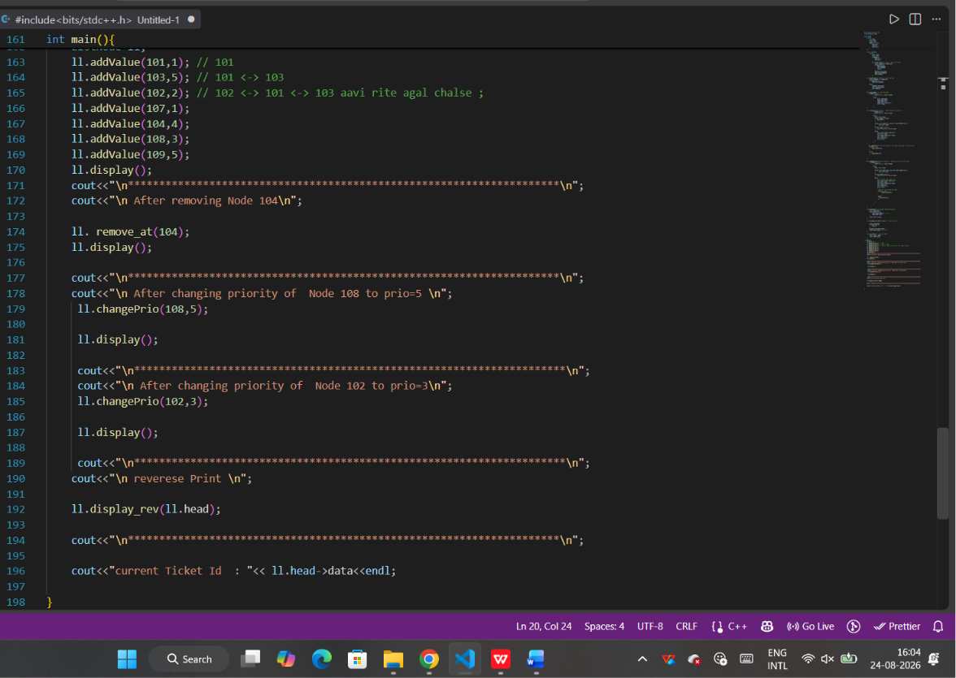

OUTPUT :

Given in next page;
